Instructions for installing Miniconda and Running a Jupyter Notebook on a Windows machine.

Miniconda is a lightweight version of Anaconda which is a distribution of Python. Jupyter notebooks provide an interactive platform for running python code.

In this document:

* Steps to download and install Miniconda
* Setting up a virtual environment
* Steps to download the packages required for ENEL 441 and ENEL ???
* Steps to run a Jupyter Notebook

Downloading and Installing Miniconda

1. Go to the website: [https://docs.conda.io/en/latest/miniconda.html](https://docs.conda.io/en/latest/miniconda.htmlc) and click on link to download windows 64bit version of the installer:

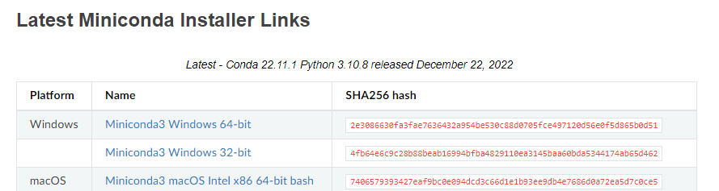

Run the installer. Make sure you run it locally (this should be the default).

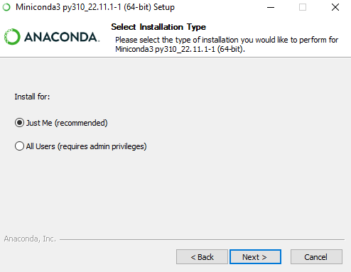

Finish installation using all the defaults.

Click on the Windows Start Menu, open Anaconda Prompt. This should open a window that looks like this:

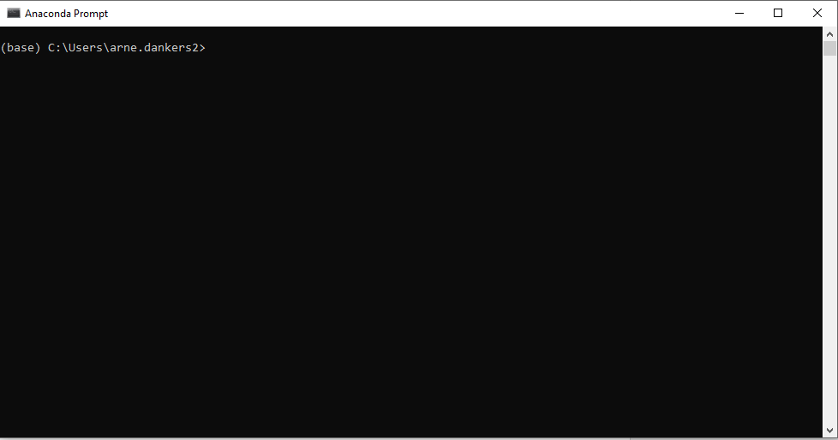

When using Python it is a good idea to create Virtual Environments. This allows you to download different versions for packages in each virtual environment. In the next steps we will create a new virtual environment where we will download all the packages for the ENEL441 course. To do this: at the prompt type in:

>>conda create -n enel441 python=3.9

You will be prompted to proceed, type ‘y’ for yes.

This creates a virtual environment called enel441.

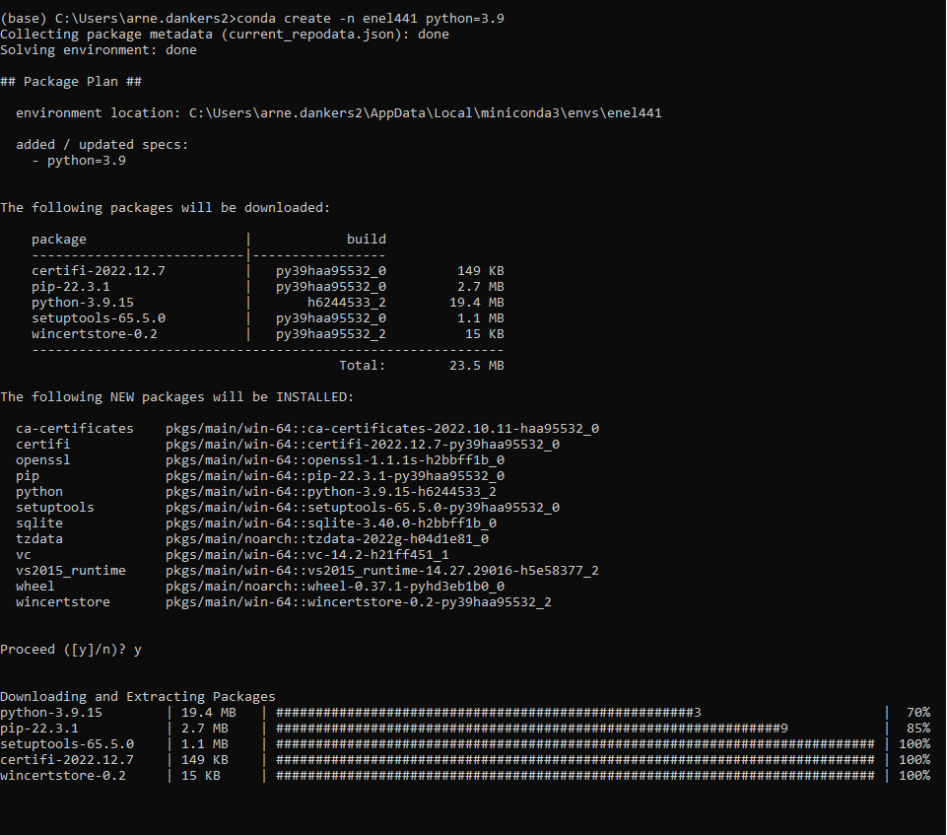

Now we will activate the environment. Type:

>>conda activate enel441 

Note that the text in bracket preceding the prompt has changed. This indicates which environment is active.

Now we will install the required packages.

>>conda install numpy jupyter scipy matplotlib

You will be asked to confirm the installation. Type ‘y’ in the prompt.

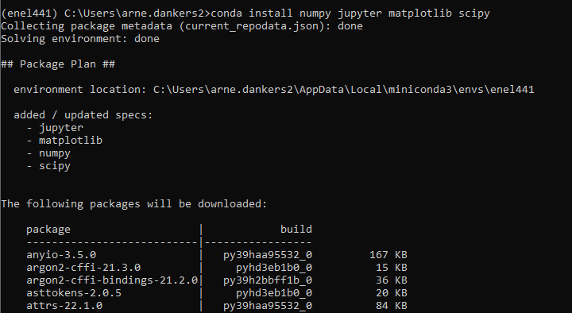

Plus more text will appear below this.

Wait until you see the following text in the window:

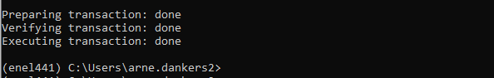

Now install control package:

>>conda install -c conda-forge control

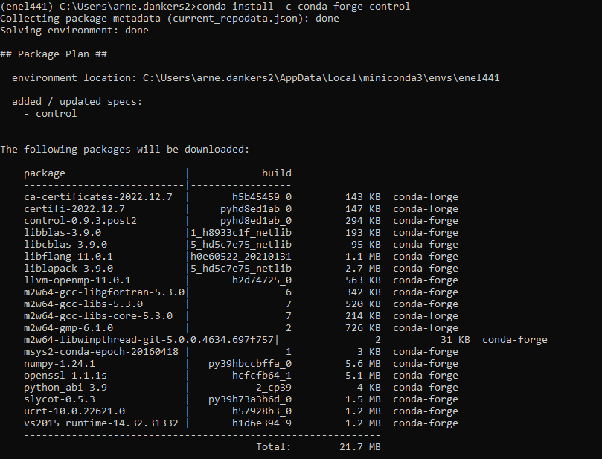

It will print a message about upgrading/downgrading some packages. Just type ‘y’ to accept.

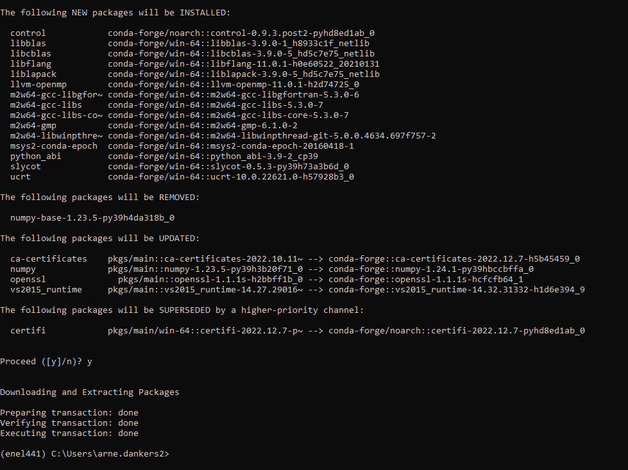

Now we have completed installing the python packages that we will need. In the following steps we will see how to launch a Jupyter Notebook. Make sure the enel441 environment is active.

At the miniconda prompt type:

>>jupyter notebook

This will open a window in your browser. Or it might open a new browser. The browser page will look like:

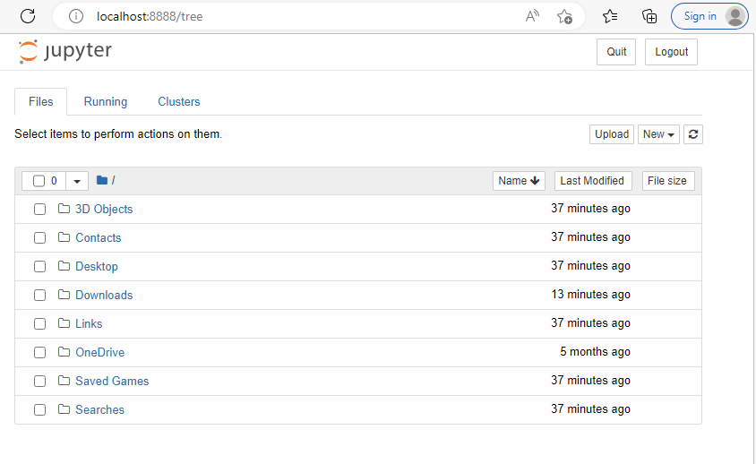

Make a folder. I made one on the desktop called ENEL441, then I made another folder in ENEL441 called Lab1. Use the mouse to click to the folder you wish to store your notebook:

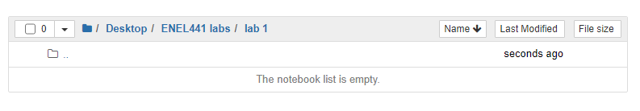

Then click on the ‘New” button:

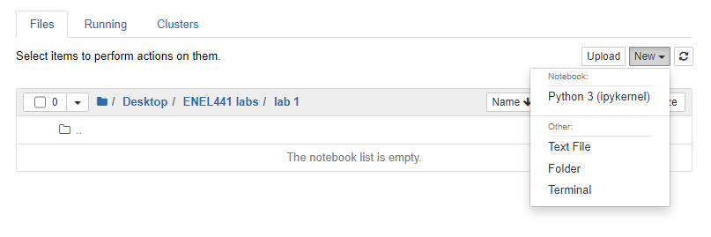

And select Python 3 (ipykernel)

This should start a new notebook. :

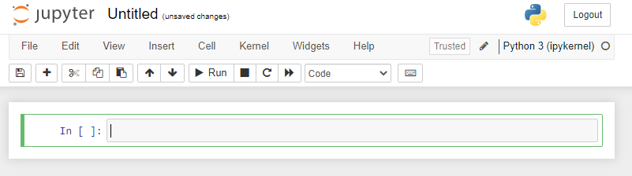

Click on ‘File’ then ‘save as’ to rename and save the file.

You are now ready to run python code in the notebook!